**Jbs Project Srls**

via savona 123 Milano

info.jbsproject@gmail.com

Personal GPS manager

10 maggio 2023 revision 1.2

**Descrizione del prodotto 2**

**Hardware typology 3**

**Start to use 7**

Functionalities 7

1. by sms (already supported) 7

2. via rest api (under development) 7

SMS Configuration 7

3. Current position 7

4. Battery level 8

5. Distance alert 8

6. Remove alerts 9

Rest API configuration 9

Advanced features (under development) 9

1. Store GPS points 9

2. Enable intelligent trace 9

Technical details 10

Linkit one* 10

Error Code 14

# 

# Product description

This product is designed to be a GPS tracking unit, which is a navigation device that uses satellite navigation to determine movement and determine geographic location.

The product contains a GPS module which receives the GPS signal and calculates the coordinates. Allows you to store data (data logger). It also allows through a modem to transmit this information over the network. Satellite-based GPS tracking units work anywhere in the world using satellite technology such as GPS, GLONASS, Galileo and BeiDou.

# 

The diagram shows a typical use of the product: a user configures the device to receive information. The device is installed on various devices (cars, motorcycles, trucks, or any other place you want to monitor). The device communicates with the satellites to receive satellite information and depending on how it is configured it can send information to a specific terminal or data to a database via the GSM/LTE module.

# Hardware typology

The product is built using two types of hardware;

**Modello A -** **GP10** based on Linkit one shown in the following picture:

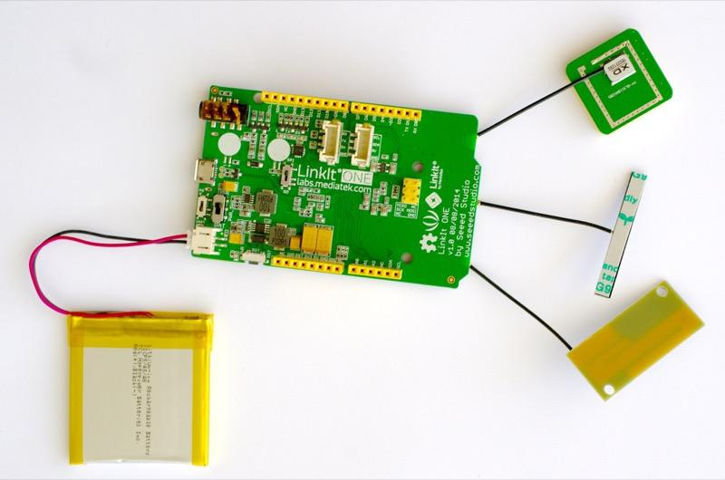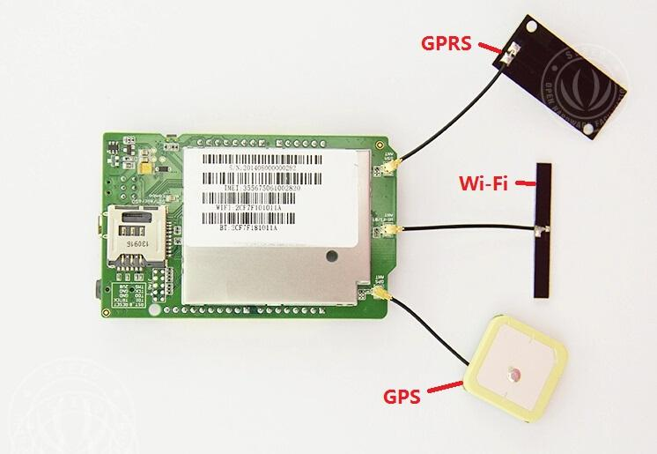

Following will be described the configuration switches:

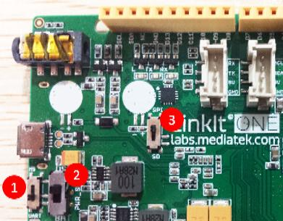

| **Switch No.** | **Functionality** | **Position 1 - Functionality** | **Position 2 - Functionality** |
| --- | --- | --- | --- |
| 1 | Program Mode | **MS：** In this position, when connected to a PC, LinkIt One board will be shown as a 10MB USB drive. The program will not execute in this mode. Any file that is copied to this drive can be read via the code. | **UART：**This position is used to set the board to program mode. Firmware can be uploaded in this mode. |
| 2 | Power | **BAT：** Board powered by Li-ion Battery. To charge the battery, set the switch to this position and connect the board to the PC. | **USB：**Board powered by USB port. Set the switch to this position when there is no battery connected to program the board. |
| 3 | SDI/SPI | **SPI：**This position allows access of external SPI pins (D10 - D13) | **SD：**This position allows the code to access the SD card. This mode also disables access to SPI pins (D10-D13). |

**Model B (under development)**  - Gp20 is splitted in 2 modules: processing unit (based on raspberry hw) and a GNSS/LTE module, connected by usb channel.

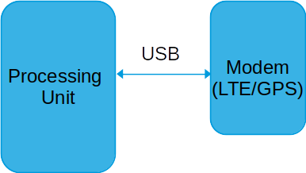

The models of the Processing unit and the GNSS/LTE module are shown below. The two modules are connected via USB.

**The two modules can change type depending on the availability of the products.**

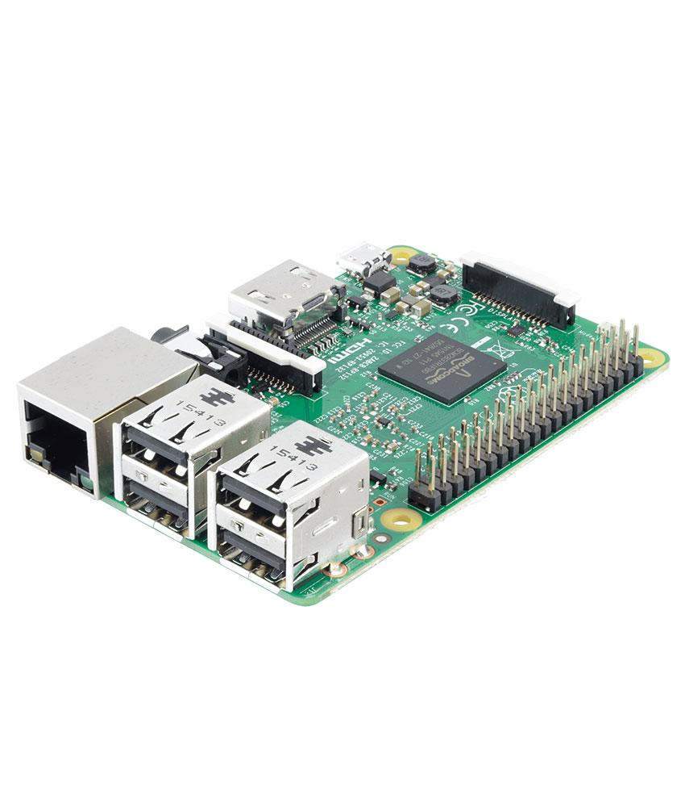 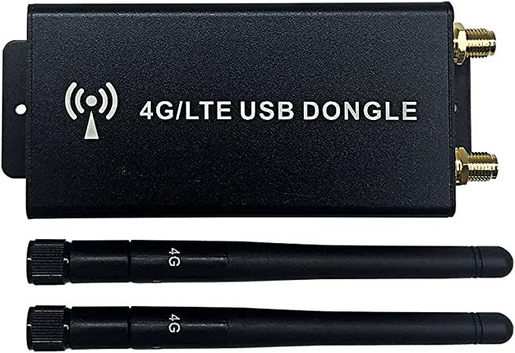

# 

# 

# 

# Start to use

Use a SIM card for a GSM network, PIN code is deactivated, no call forwarding function.

The SMS message must be in Text format, not PDU format.

# Functionalities

GPS personal tracker supports various features that make it a very simple item to set up.

The configuration is very simple and can be done in 2 ways:

##### by sms (already supported)

* 1. you send a text message to the number configured in the sim and GPS personal tracker receives the configuration and applies it providing an answer

##### via rest api (under development)

* 1. you can send configuration commands through REST api

## SMS Configuration

It is possible to activate many functions by sending text messages containing certain formats. NB: if the GPS is not fixed send an error.

To see the list of errors see here: Errors table

##### Current position

| **Text to send via sms** | **Response** | **Description** |
| --- | --- | --- |
| *GET CURR LOC* | lat= long=  https://googlemas… | Send via sms the current position (latitude and longitude) |

##### Battery level

| **Text to send via sms** | **Response** | **Description** |
| --- | --- | --- |
| *GET BATT* | battery level=20% | Send the current battery level |

It is possible to set a periodic communication of the battery level using this message:

| **Text to send via sms** | **Response** | **Description** |
| --- | --- | --- |
| *GET BATT PERIODIC* | battery level=80% | Sends the current battery level every 10 minutes |
| *GET BATT PERIODIC OFF* | OK | disables the periodic sending of the battery level |

##### 

##### Distance alert

##### 

| **Text to send via sms** | **Response** | **Description** |
| --- | --- | --- |
| *SET ALARM <lat=x,long=x> <distance>* | ALERT DISTANCE | Sets an alarm if the distance from the point entered with the coordinates exceeds <distance>. distance is expressed in meters. The alert is sent every 10 minutes. |
| *SET ALARM OFF* | OK | remove distance alert |

##### 

##### Remove alerts

| **Text to send via sms** | **Response** | **Description** |
| --- | --- | --- |
| *ALERT OFF* | OK | remove all alerts |

##### 

## Rest API configuration

Under development

# Advanced features (under development)

##### Store GPS points

writes GPS points every 30 minutes on memory card (can export them in a format to display them on a map).

##### Enable intelligent trace

Enable intelligent tracking that provides information about the optimal use of transportation (requires payment of a subscription for the use of a backend part)

## 

## 

## 

## 

## Technical details

## 

## Linkit one*

| Dimensions | 108mm x75mm x33mm |
| --- | --- |
| Weight | G.W 102.5g |
| Battery | Lithium Cells/Batteries packed with equipment UN3481 -PI966 |
| Microcontroller |  |
| Chipset | MT2502A (Aster) |
| Core | ARM7 EJ-S™ |
| Clock Speed | 260MHz |
| Dimensions | 3.3 x 2.1 inches |
| Flash | 16MB |
| RAM | 4MB |
| Battery Jack | 3.7~4.2V Li-battery |
| DC Current Per I/O Pin | 0.3~3mA |
| Pin Count | 16 (D0~D13, SDA, SCL) |
| Voltage | 3.3v |
| Pin Count | 3 (A0, A1, A2) |
| Voltage | 0~5V |
| Pin Count | 2 (D3 and D9) |
| Voltage | 3.3v |
| Max Resolution | 13bit |
| Frequency (Resolution) | 1.6KHz (13bit) / 50.8KHz (8bit) / 800KHz (4bit)/ (customizable) |
| Pin Count | 2 (D2 and D3) |
| Set Count | 1 (SDA, SCL) |
| Speed | 100Kbps, 400Kbps, 3.4Mbps |
| Set Count | 1 (MOSI, MISO, SCK, SS) |
| Speed | 104Kbps~26Mbps |
| Set Count | 1 (TX/RX) |
| Voltage | 3.3v |
| Set Count | 1 |
| GSM | 850/900/1800/1900MHz |
| GPRS | Class 12 |
| Bluetooth | BR/EDR/BLE (Dual Mode) |
| Wi-Fi (MT5931) | 802.11 b/g/n |
| GPS (MT3332) | GPS/GLONASS/BEIDOU |
| Flash | 10MB |
| SD Card | Up to 32GB (Class 10) |
| RAM (Code+RO+RW+ZI+Heap) | 2MB |

**Part List**

| LinkIt One | 1 |
| --- | --- |

ECCN/HTS

| HSCODE | 8543709990 |
| --- | --- |
| USHSCODE | 8543709301 |
| UPC | 841454106326 |
| EUHSCODE | 8543709099 |
| COO | CHINA |

| CE |  |
| --- | --- |
| EU DoC |  |
| FCC |  |
| RoHS |  |



Polymer li-ion Battery

(*) source: <https://www.seeedstudio.com/>

## Error Code

| Code | Description |
| --- | --- |
| 2 | GNSS not fixed |
| 10 | generic error |
|  |  |

History

| **Date** | **version** | **Description** |
| --- | --- | --- |
| 1/5/2023 | 1.0 | creation |
| 10/5/2023 | 1.1 | functionalities description |
|  |  |  |
|  |  |  |